FRONT END & BACKEND
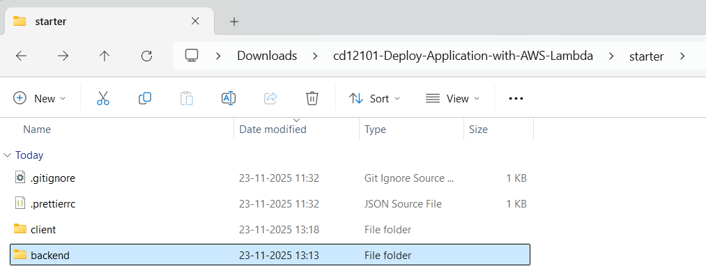

NODE MODULES IN BACKEND
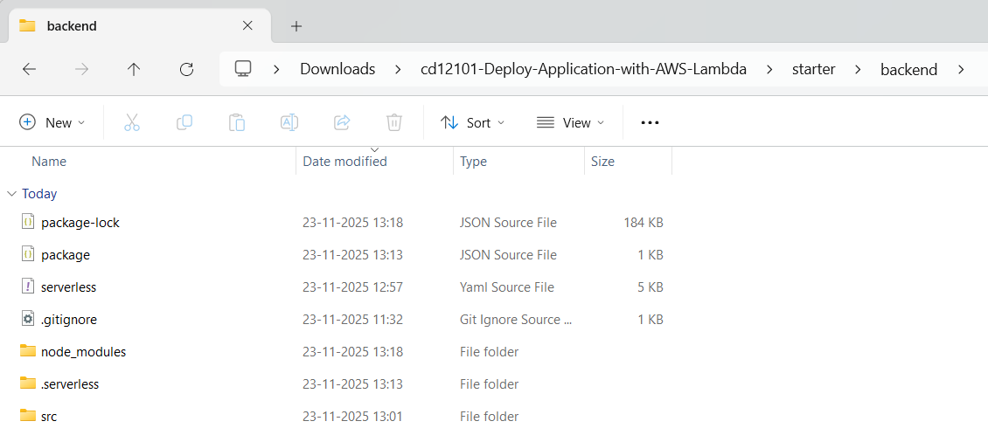

SERVERLESS.YML AND PACKAGE.JSON
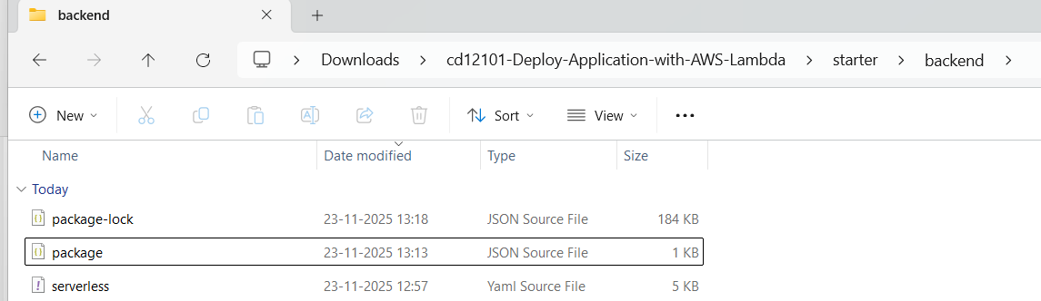

CREATE AND UPDATE SCHEMA
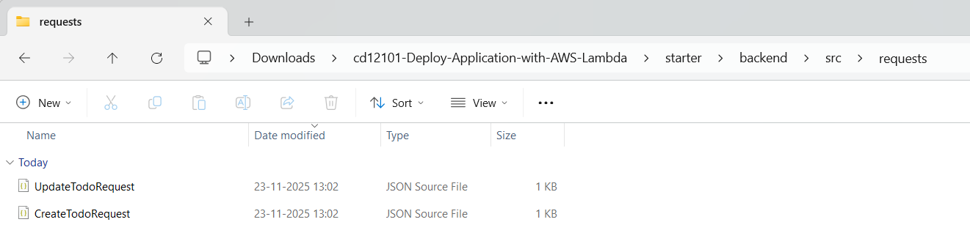

BUSINESS LOGIC
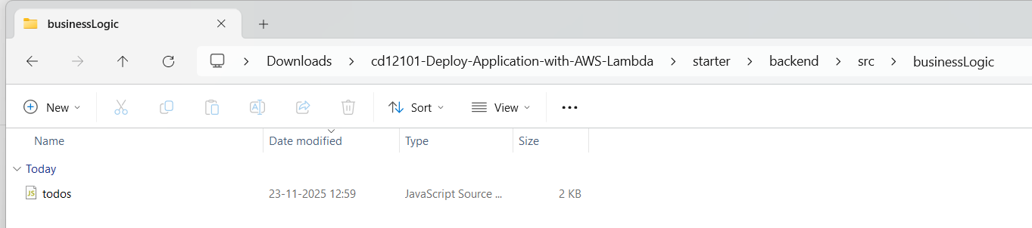

DATALAYER
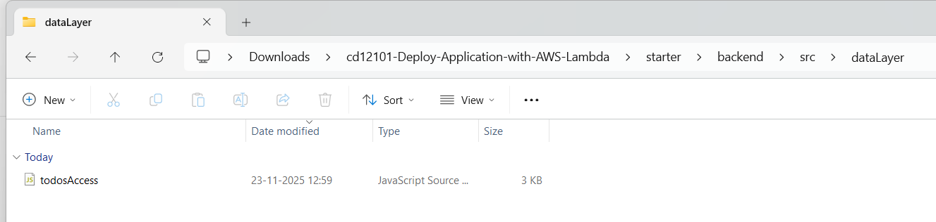

FILESTORAGE
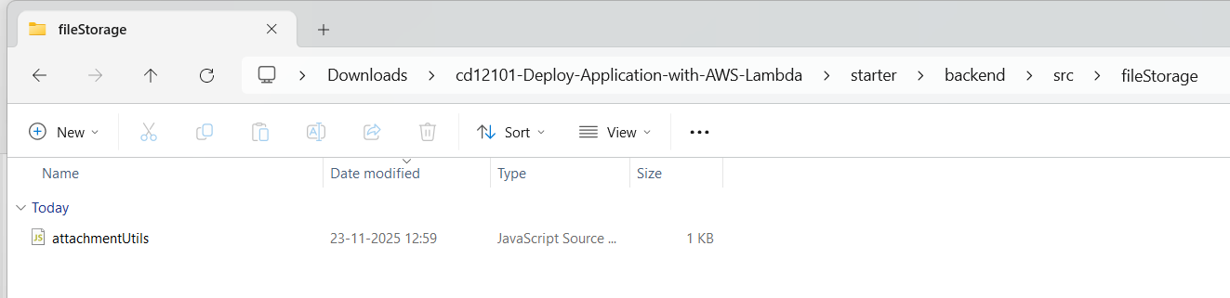

UPDATED HTTP FILES
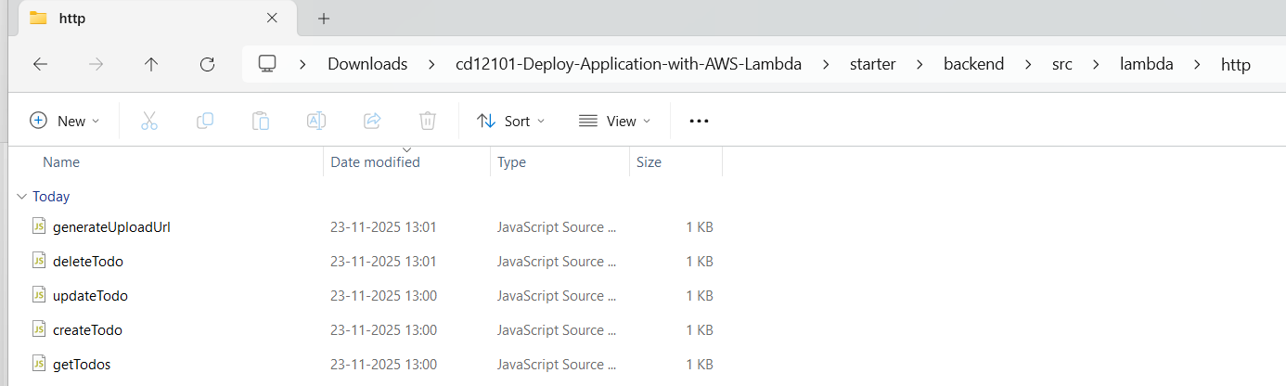

AUTH0 AUTHORIZER
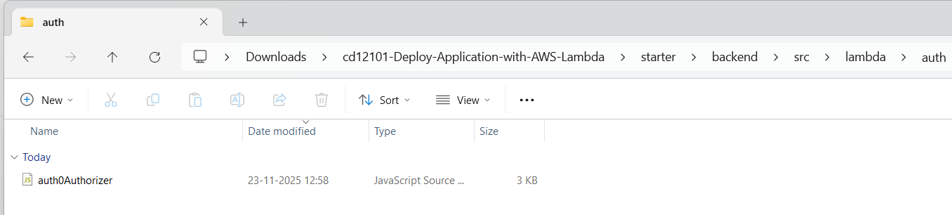

UTILS LOGGER
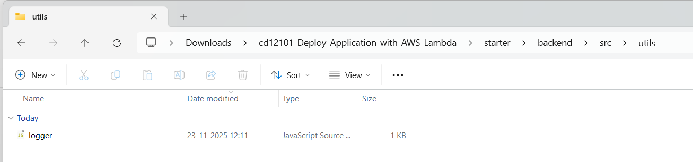

CLIENT .ENV
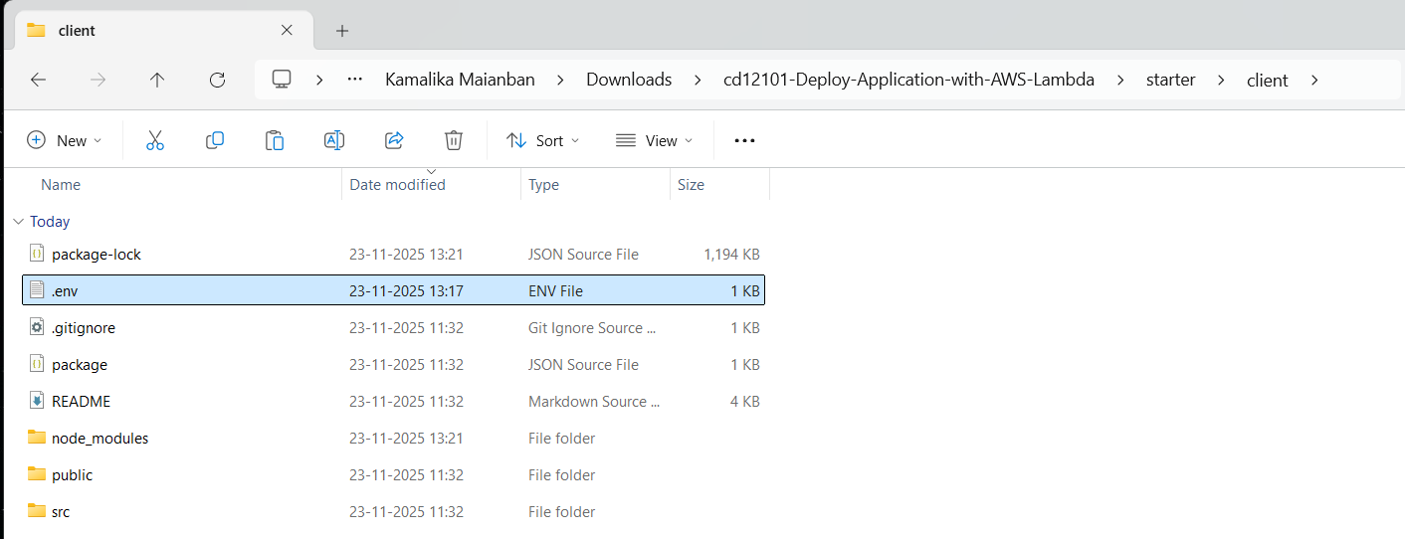

FILES AND ITS PATH
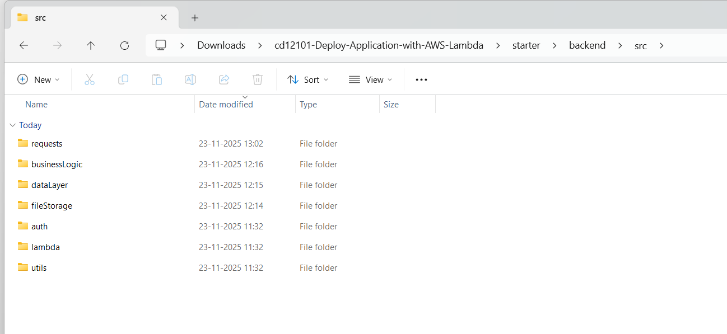
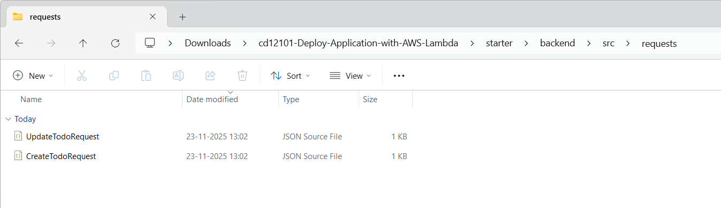
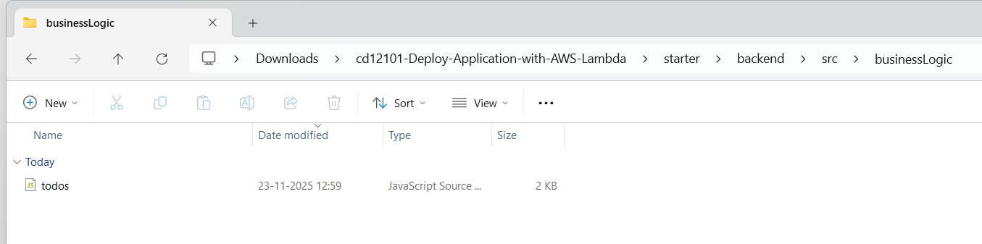
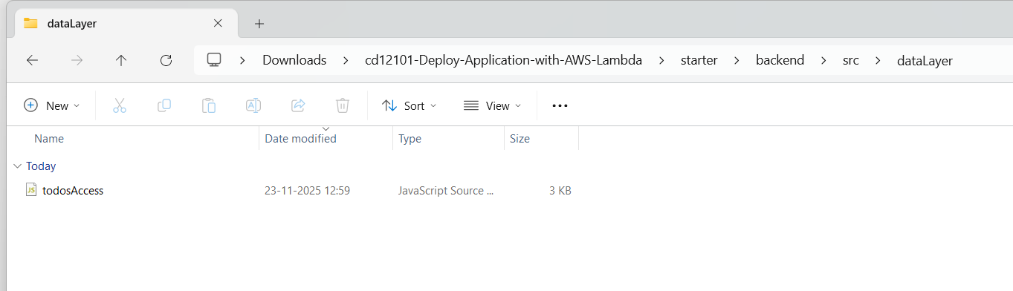
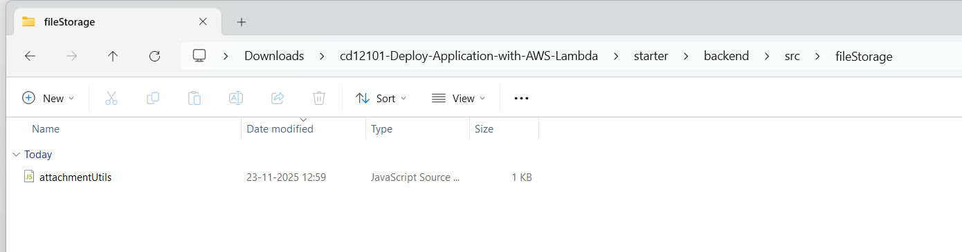
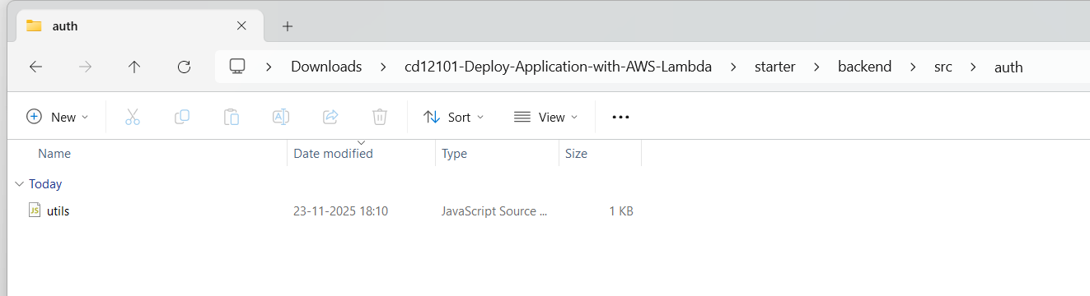
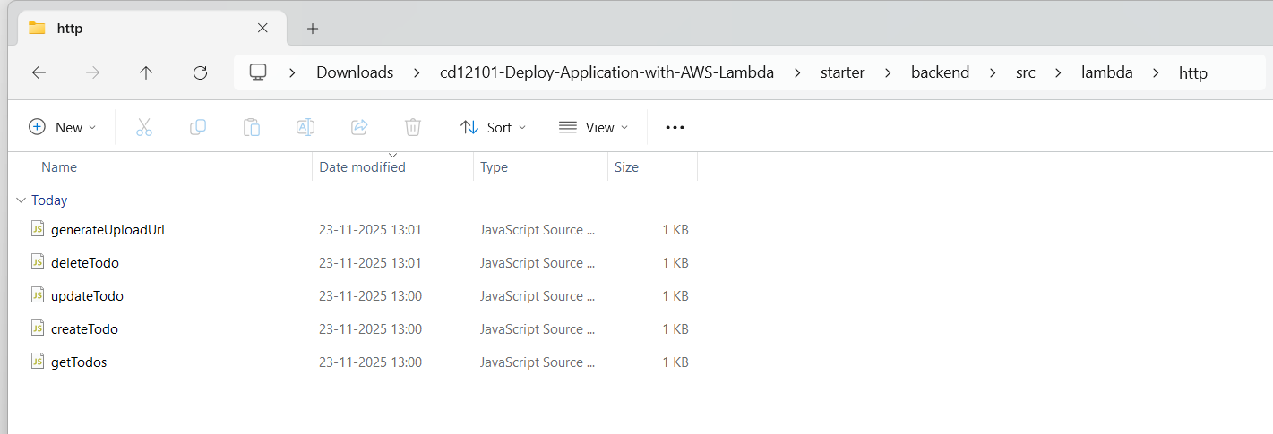
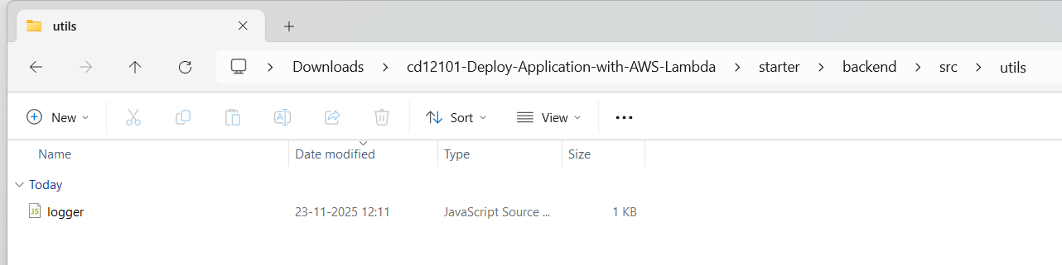

LOGIN PAGE
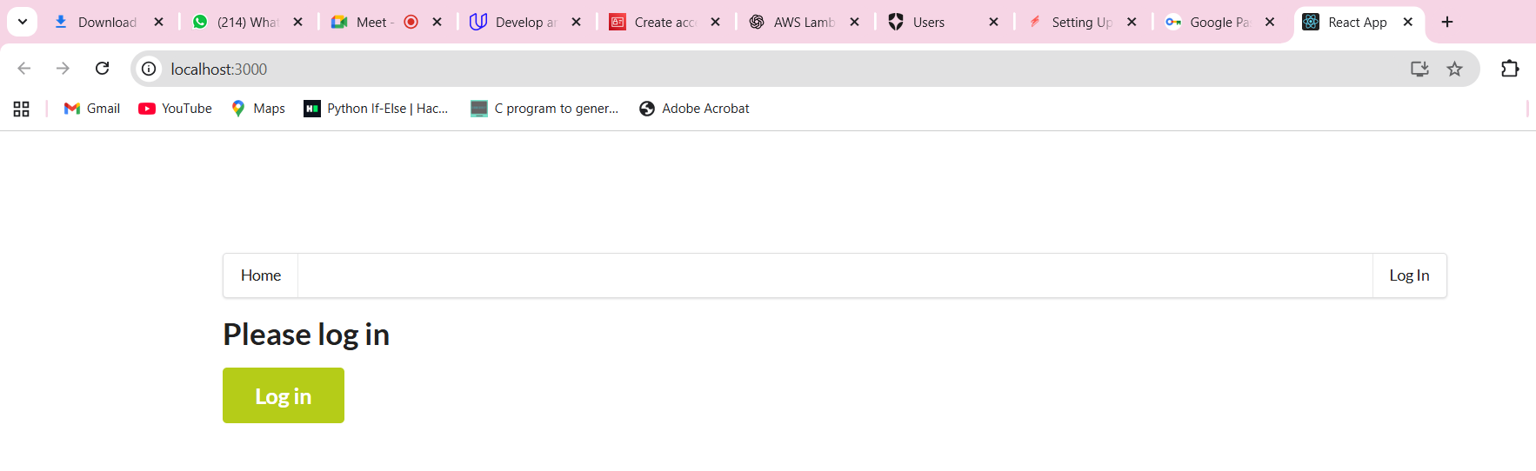

LOGIN AUTH0
